**Snnifing**

sniffing is the act of intercepting and monitoring traffic on a network. This can be done using software that captures all data packets passing through a given network interface or by using hardware devices explicitly designed for this purpose.

Descriptions: In this project for performing all task we need an environment in virtual space with two or more systems.

Tools: Ettercap, Bettercap, Evilfoca, Wireshark, Netcat, etc.

**● Set up an environment in the virtual space that replicates the organization’s two or more computer systems sharing data with each other**

**● Establish the environment that will allow the attacker machine sniffing attack in the same network.**

**● Download and install all the required tools for sniffing and spoofing**

The lab is already satisfied with all requirements included in task

The system we have in lab is:

->Windows 11

->Windows server 2022

->windows server 2019

->parrot

**● Demonstrate the techniques by which the attacker can sniff the data of two or more communicating devices in the organization over IPv4 and IPv6.**

The wireshark is used for sniffing,capturing and monitoring the packets over the network, through it we can get packets,data,protocol,ip …etc

We are performing sniffing and analysis of packets. Capturing it monitoring it review protocols ,ip, services,version over the tcp/ip with both ipv4 and ipv6 protocols.

**Wireshark:**

Wireshark is a free and open-source packet analyzer. It is used for network troubleshooting, analysis, software and communications protocol development, and education. Originally named Ethereal, the project was renamed Wireshark in May 2006 due to trademark issues.

**Dashboard:**

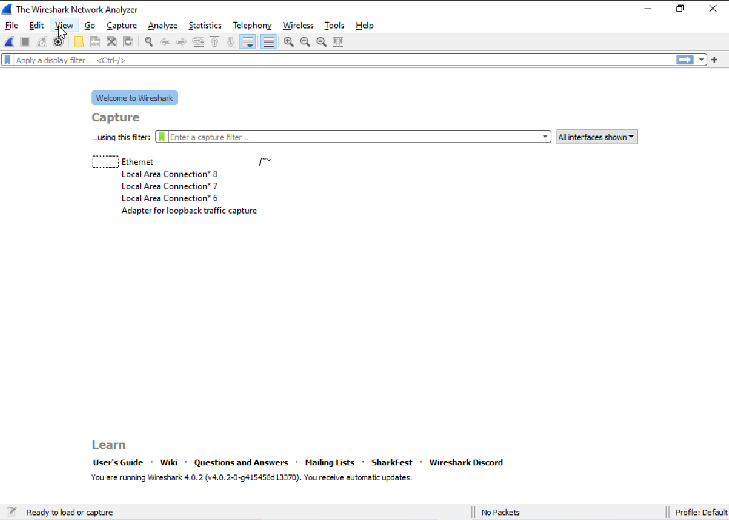

We can see the source ,destination,protocol,info whatever Is running on network

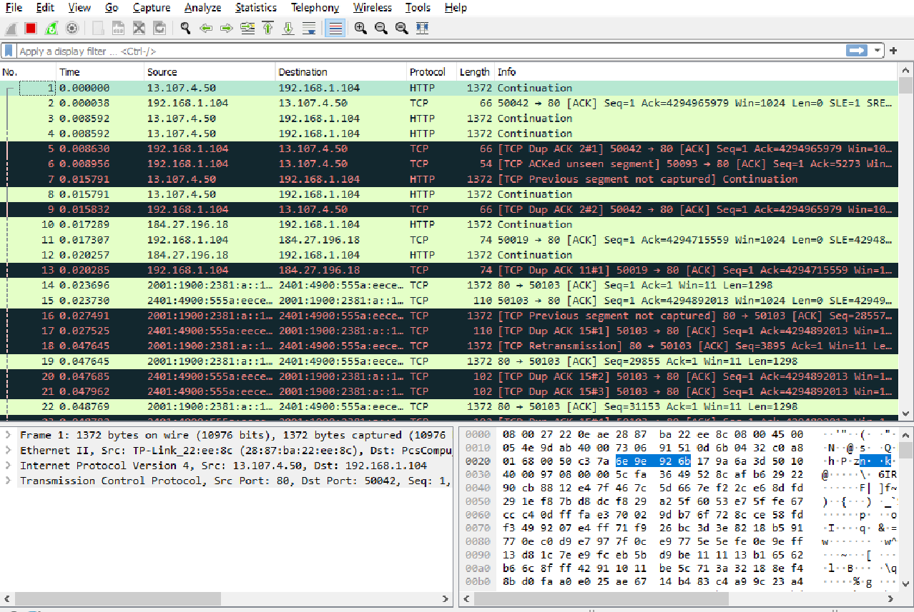

**Ipv4 packet:**

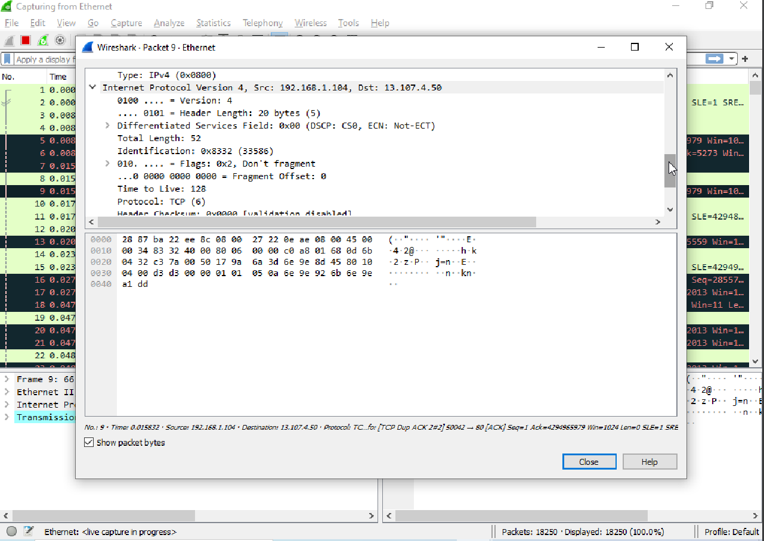

**Ipv6 packet:**

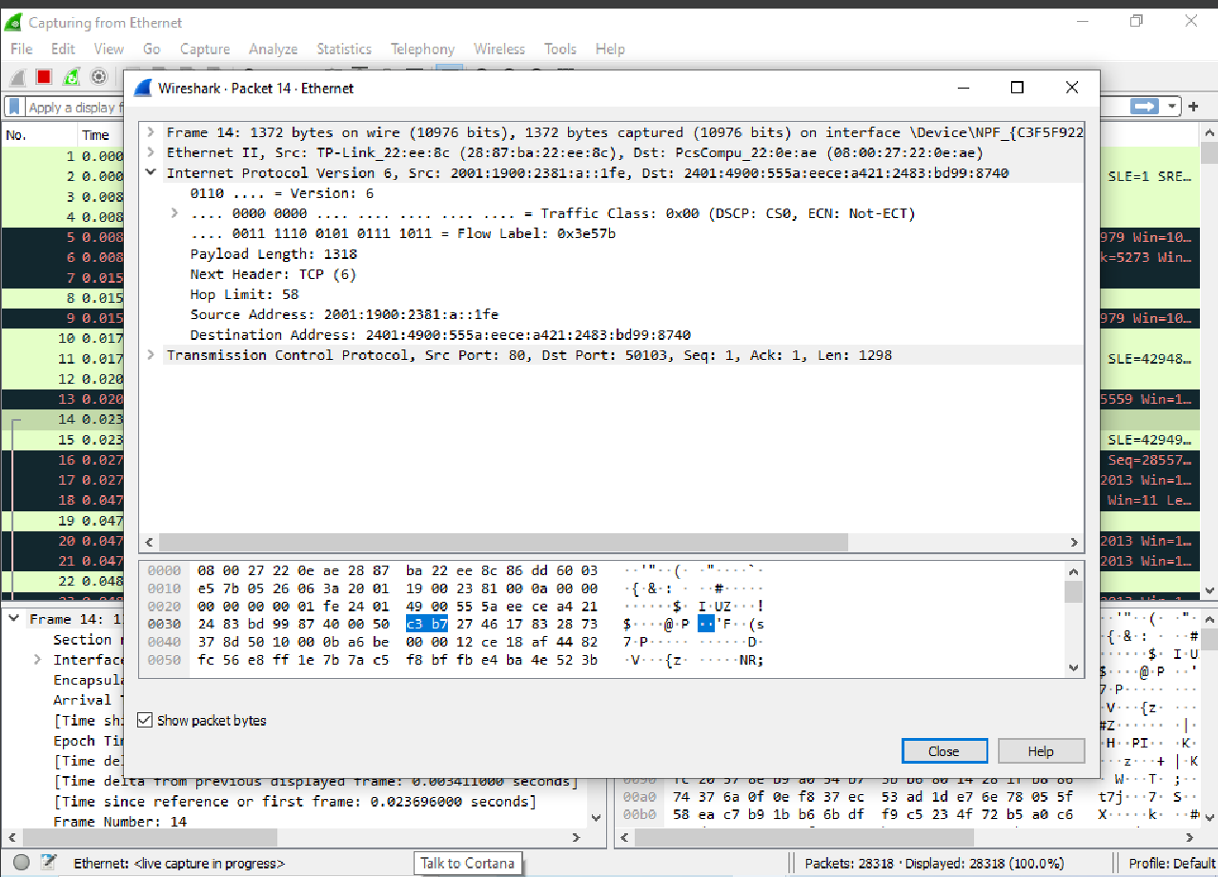

We are going to perform a scan on wireshark with testing websites

Capturing the packets and see the information of it

WEBSITES: <http://testphp.vulnweb.com/>

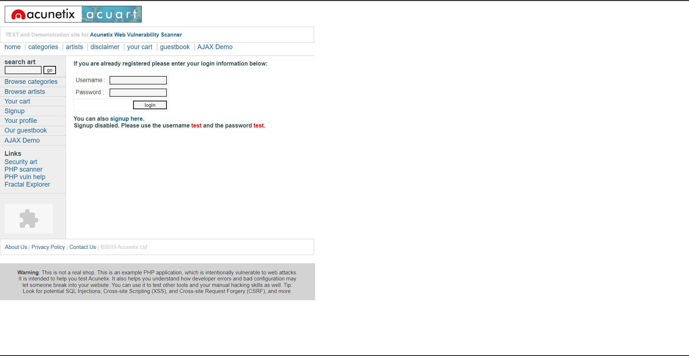

We are capture the login packets in wireshark

**Wireshark demonstration:**

**The packets:**

In the wireshark packet we can get information like

Interface,encapsulation type,time etc..)

the wireshark packet look like this:

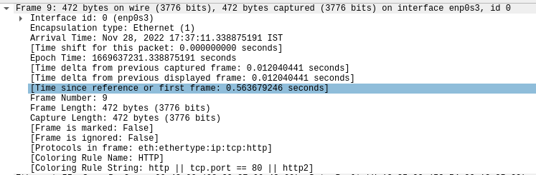

**Source/destination IP:**

It’s show’s as the source as well as the destinations ip

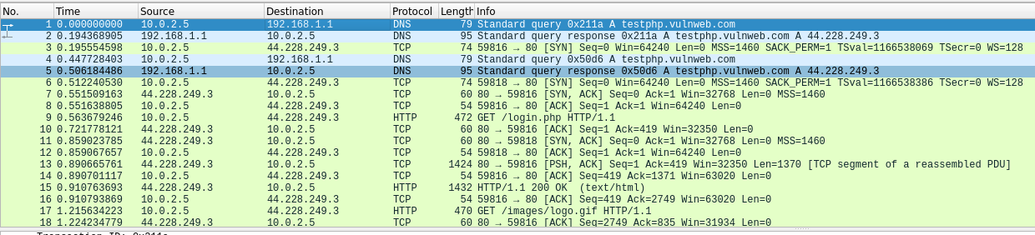

In the above pictures we can see source/destination for each and every packet.

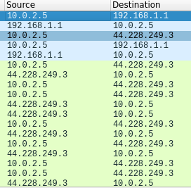

**Request:**

**GET**

In the request packet we can get some important information’s like(Browser,

Browser version,Operating system,Lanuguages,Host,Http version,etc) which is presented in image below

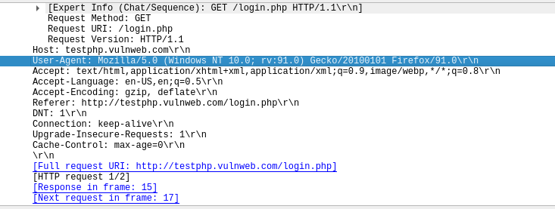

**POST**

In this we can get information like server,server version,programming language,programming language version,os and os version etc..)

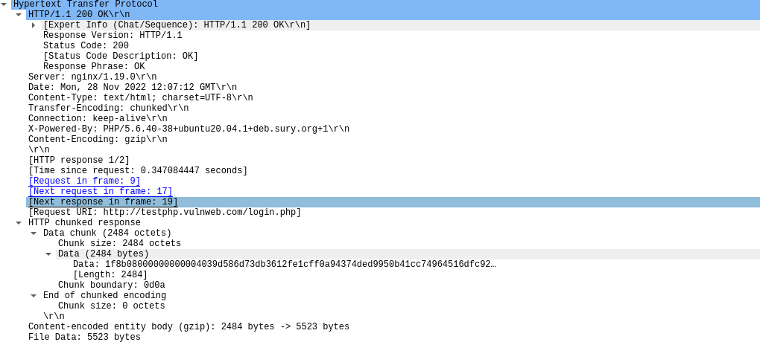

**Critical information :**

Some times when the website is vulnerable than its show’s some critical information publicly

**Ex:** page source code, Login credentials, Different Keys

**TLS(transport layer security) :**

In this we can see the versions, and encrypted application data

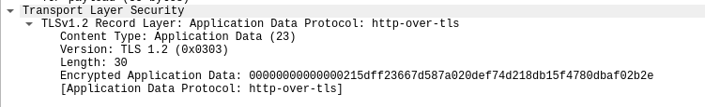

**Page source code:**

In this we can see the page source, sometimes page source is really usefull

Because in that an attacker able to find many things like(other webpages, directory’s, programming language’s, Developer’s comment’s,misconfigrations,business logic flow’s ,etc..)

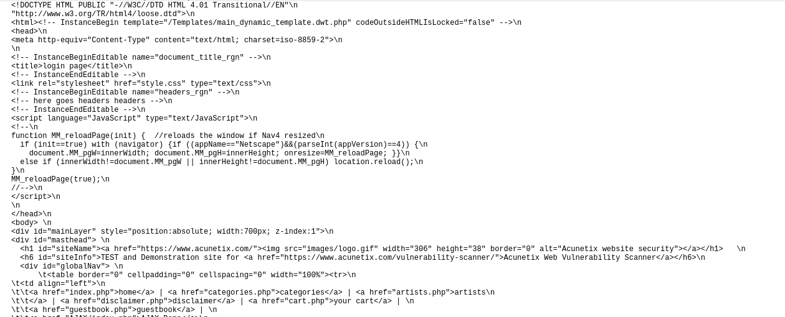

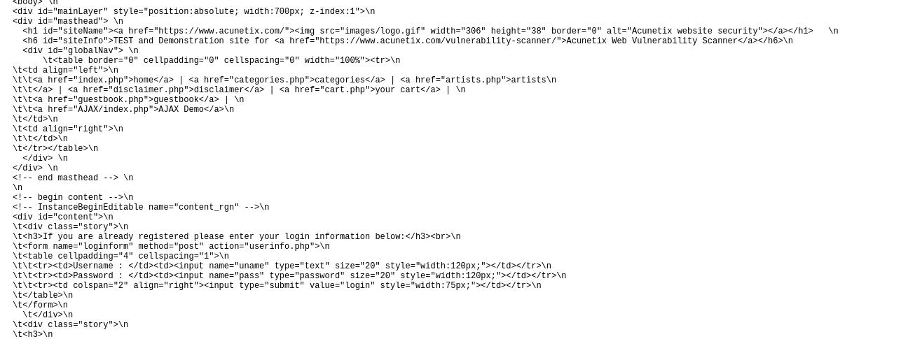

**Credentials:**

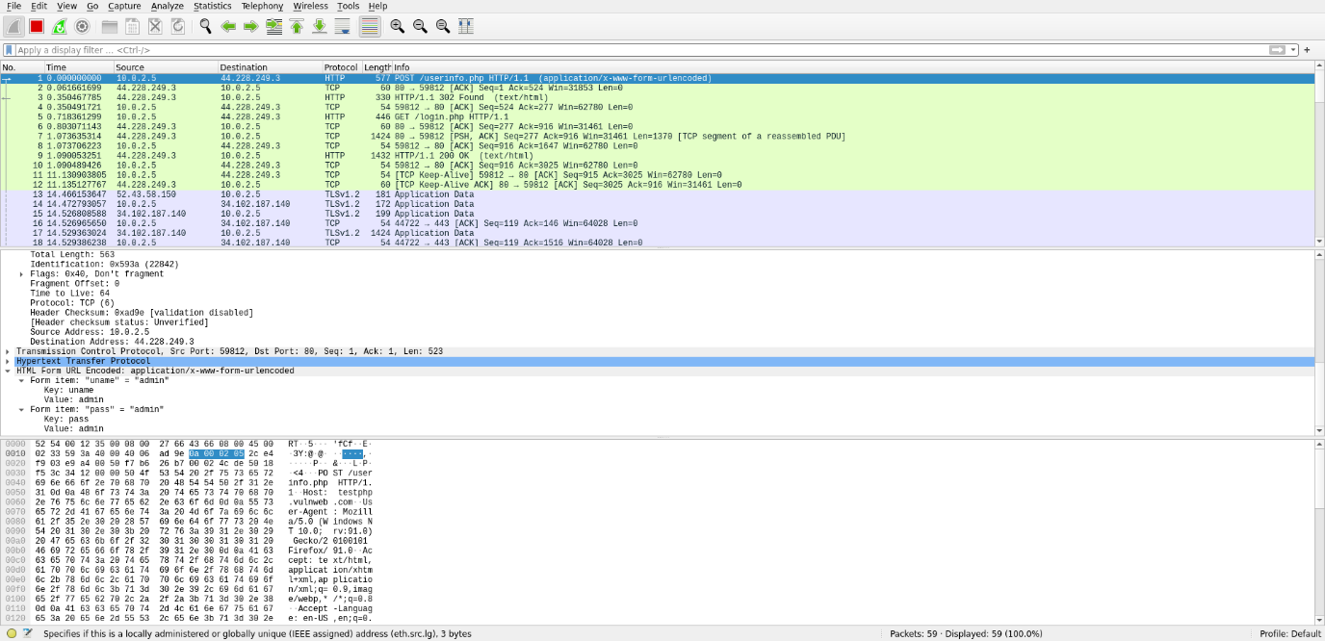

**The Packet:**

The packet which we can see is in a blue color



**Credential:**

We can clearly see the credentials

Username:admin

Password:admin

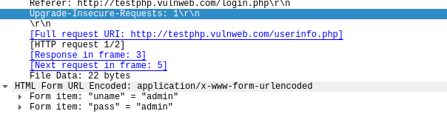

**Foca:**

FOCA (Fingerprinting Organizations with Collected Archives) is a tool that reveals metadata and hidden information in scanned documents. These documents are searched for using three search engines: Google, Bing, and DuckDuckGo. The results from the three engines amounts to a lot of documents. FOCA examines a wide variety of records, with the most widely recognized being Microsoft Office, Open Office and PDF documents. It may also work with Adobe InDesign or SVG files. These archives may be on-site pages and can be downloaded and dissected with FOCA.

**Dashboard**

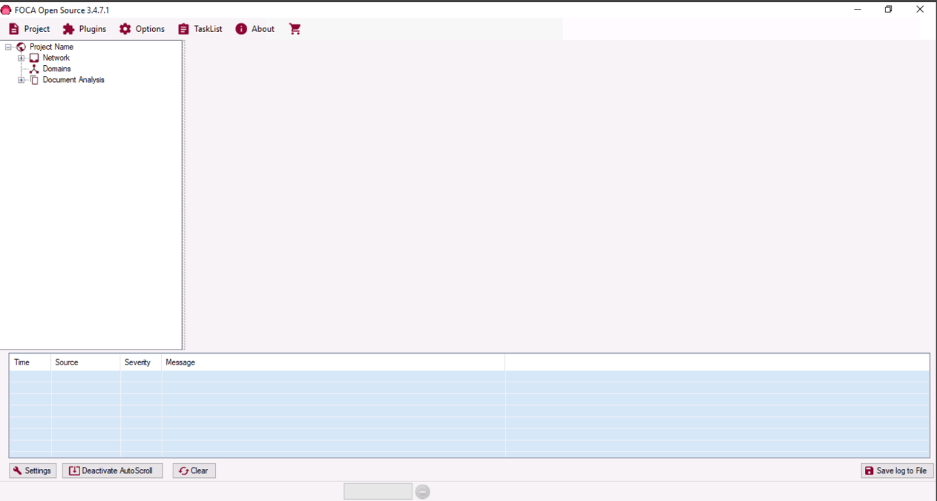

Create new project:

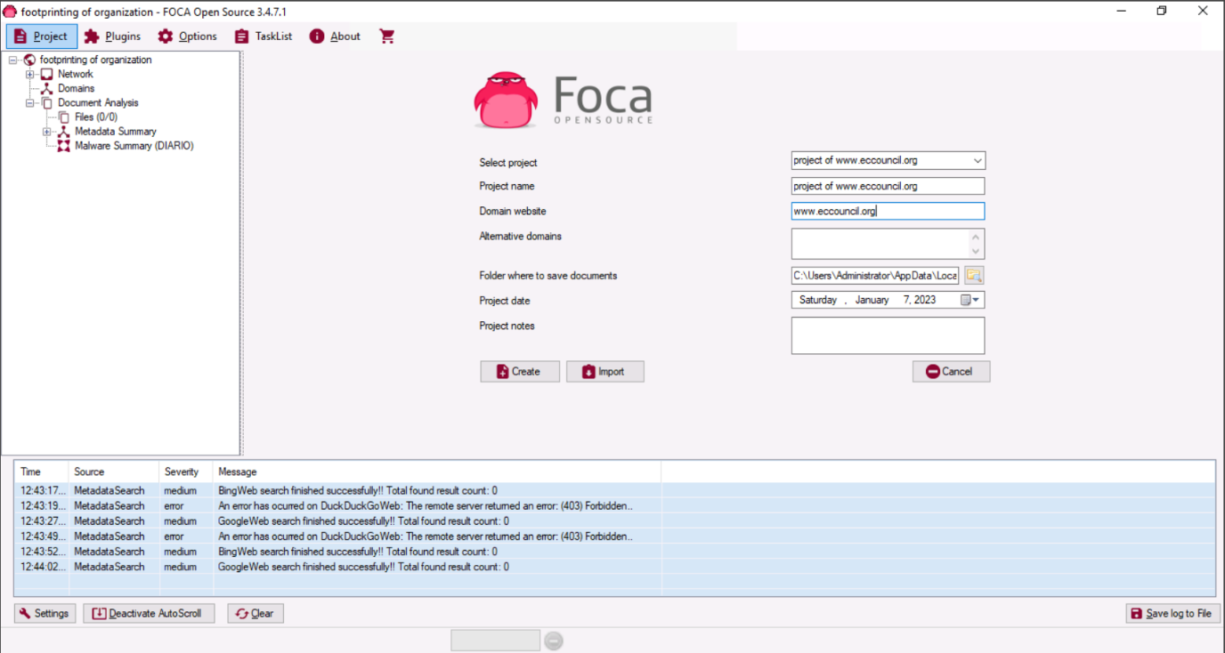

Select all three search engines Similarly, under **Extensions** section, click **All** option to choose all the given extensions and then click the **Search All** button.

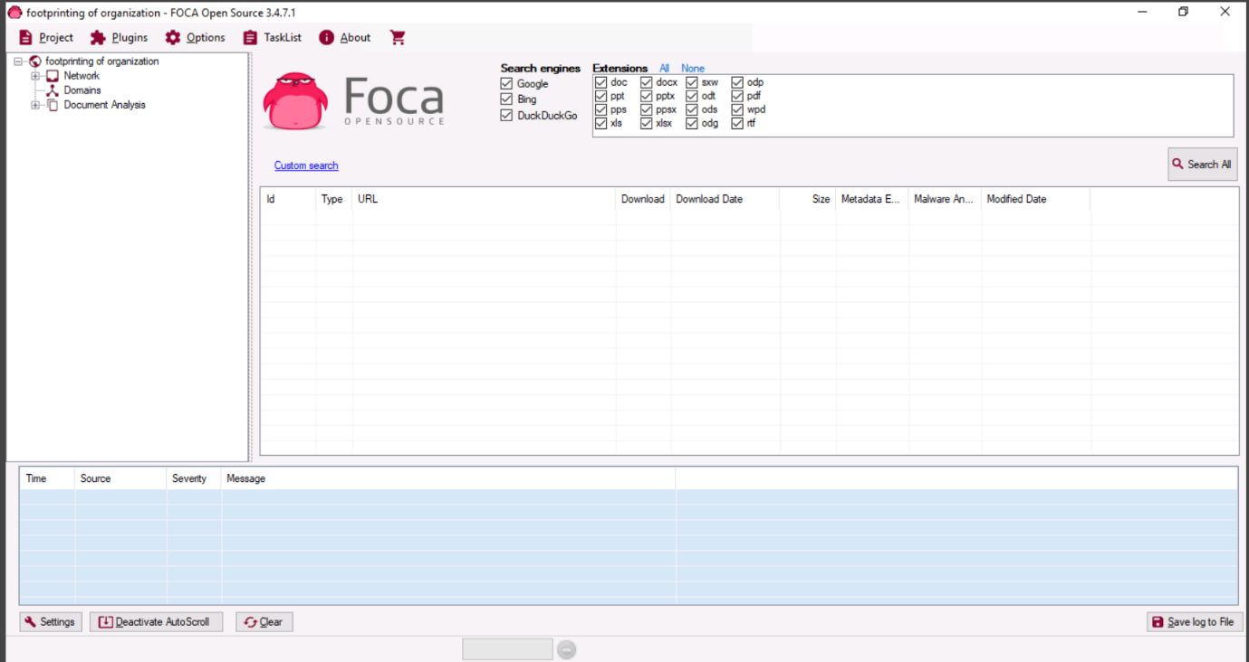

After the scans are completed. The gathered result on the Metadata associated with the target domain appears, as shown in the image

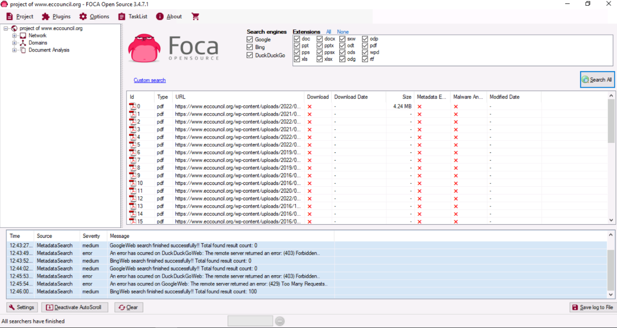

You can Download files and also open in browser through right-click on any URL and click **Link(s) --> Open in browser** from the context menu.

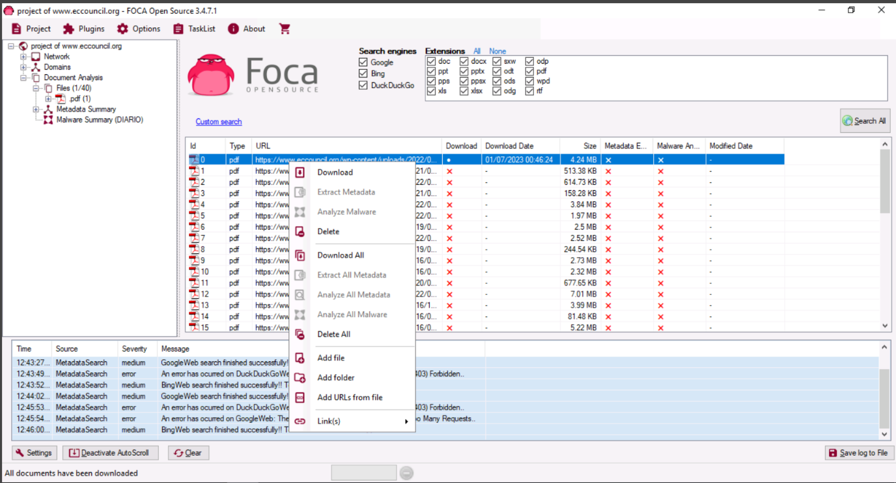

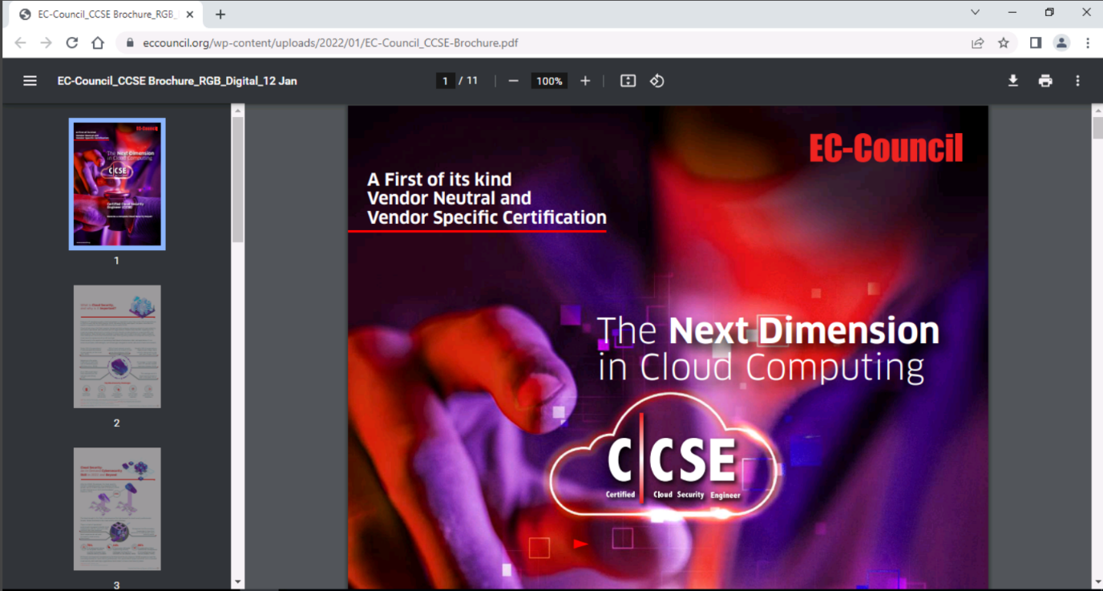

**Netcat:**

Netcat is a networking utility that reads and writes data across network connections, using the TCP/IP protocol. It is a reliable “back-end” tool used directly or driven by other programs and scripts. It is also a network debugging and exploration tool.

In this we are performing simple example

Through netcat getiing the GET request of website

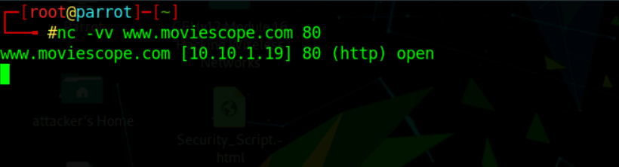

Command :GET /HTTP/1.0

We successfully got the GET request

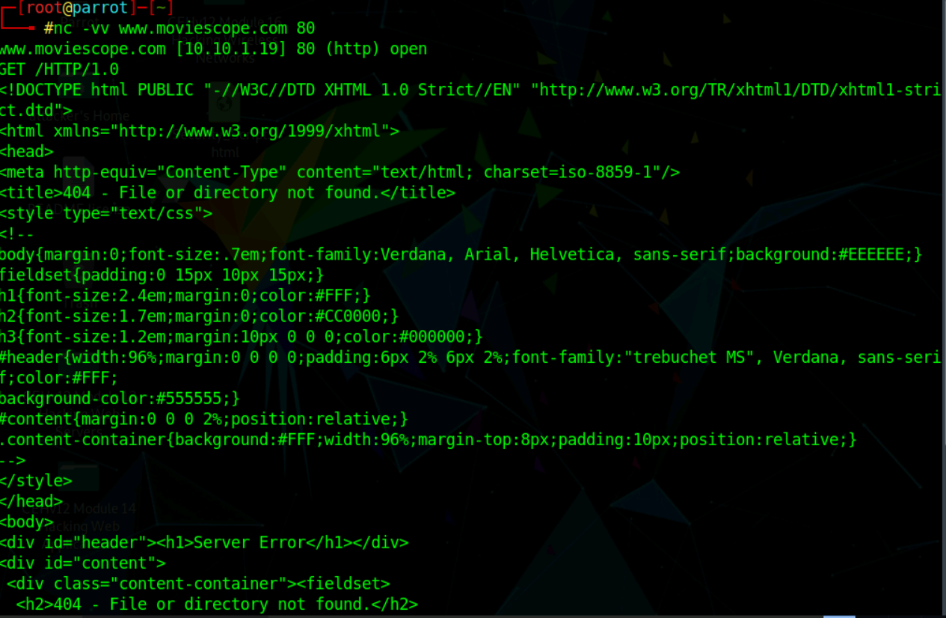

**● Steal sensitive information like passwords, keys, secrets, internal emails or credit card details from the sniffed target.**

**Bettercap:**

BetterCAP is a powerful, flexible and portable tool created to perform various types of MITM attacks against a network, manipulate HTTP, HTTPS and TCP traffic in realtime, sniff for credentials and much more.

Intercept HTTP traffic on the target system:

Command: bettercap -iface etho

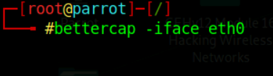

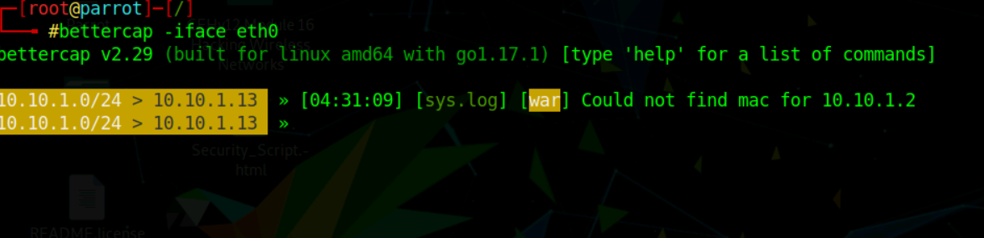

**net.probe on =** send different types of probe packets to each IP in the current subnet for the **net.recon** module to detect them.

**net.recon on =** responsible for periodically reading the system ARP table to detect new hosts on the network.

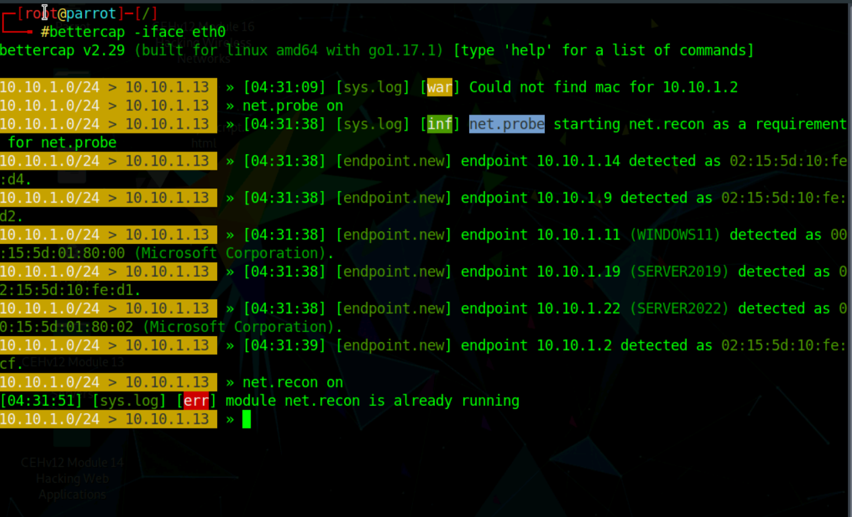

**set http.proxy.sslstrip true =** This module enables SSL stripping.

**set arp.spoof.internal true =** spoofs the local connections among computers of the internal network.

**set arp.spoof.targets 10.10.1.11=** spoofs the IP address of the target host.

**http.proxy on=** module initiates http proxy.

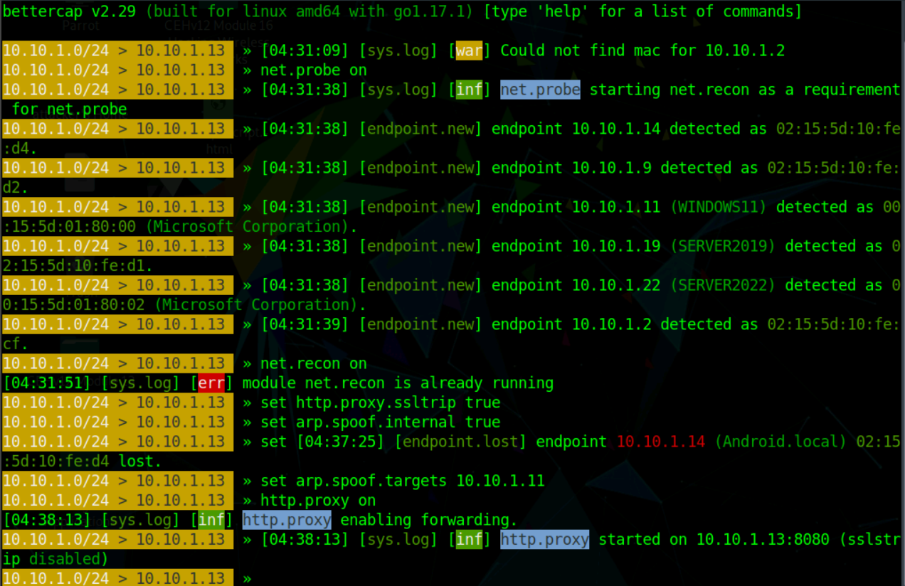

**arp.spoof on** =initiates ARP spoofing.

**net.sniff on** =responsible for performing sniffing on the network.

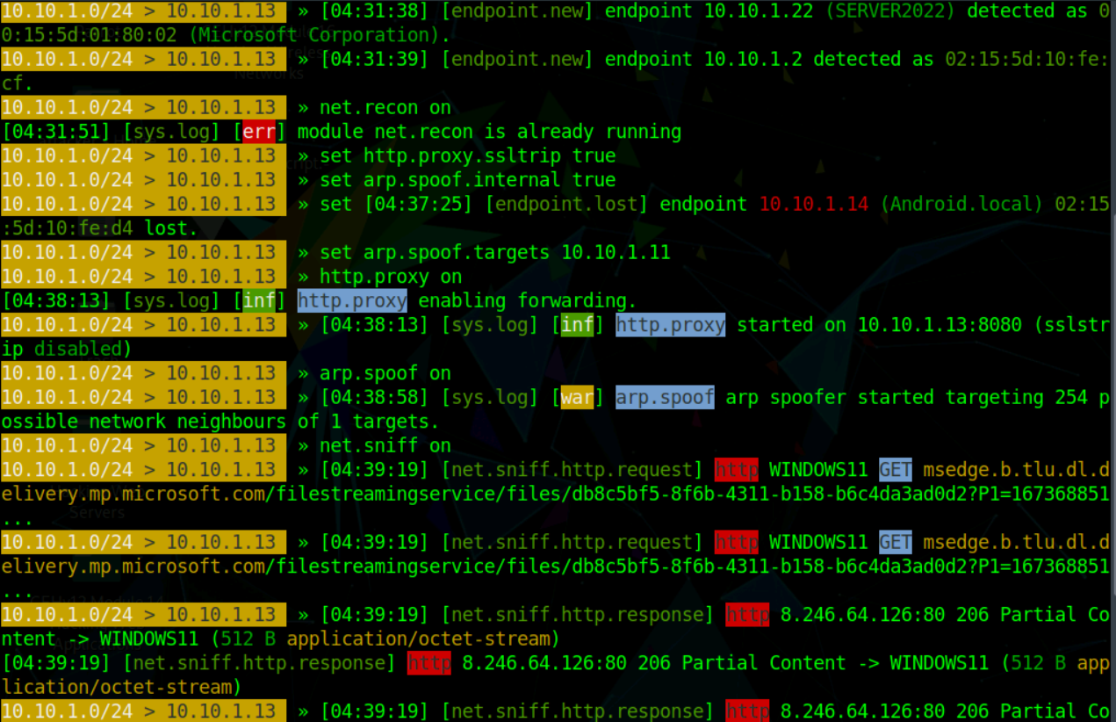

**set net.sniff.regexp ‘.*password=.+’ =** only consider the packets sent with a payload matching the given regular expression (in this case, **‘.*password=.+’**

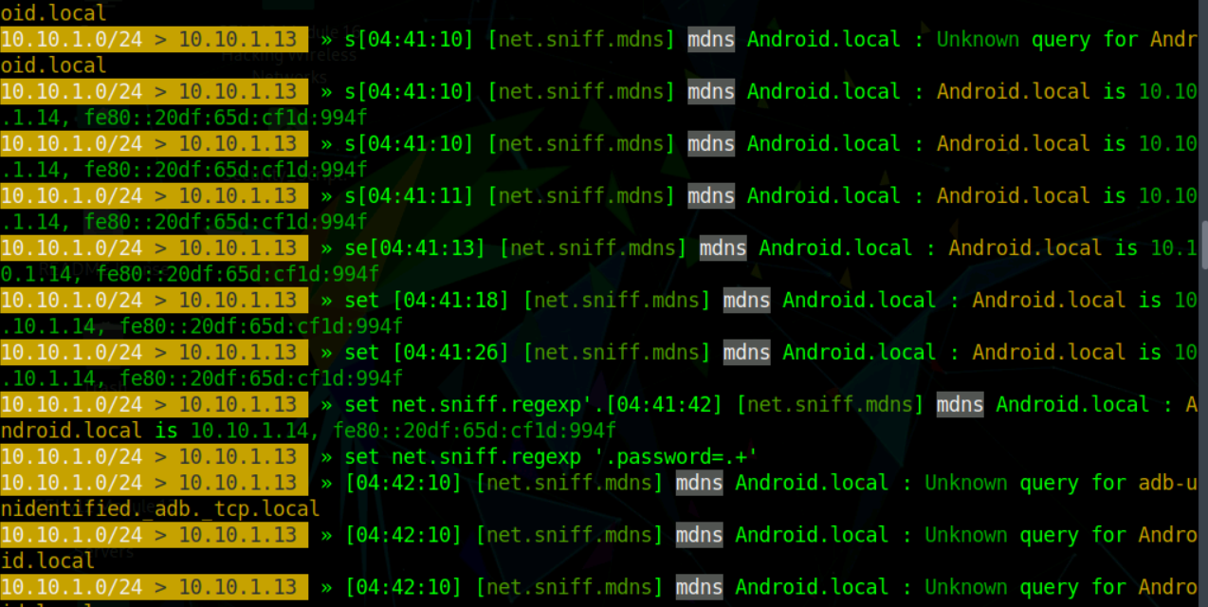

Open windows 11 browse :www.moviescope.com

Login

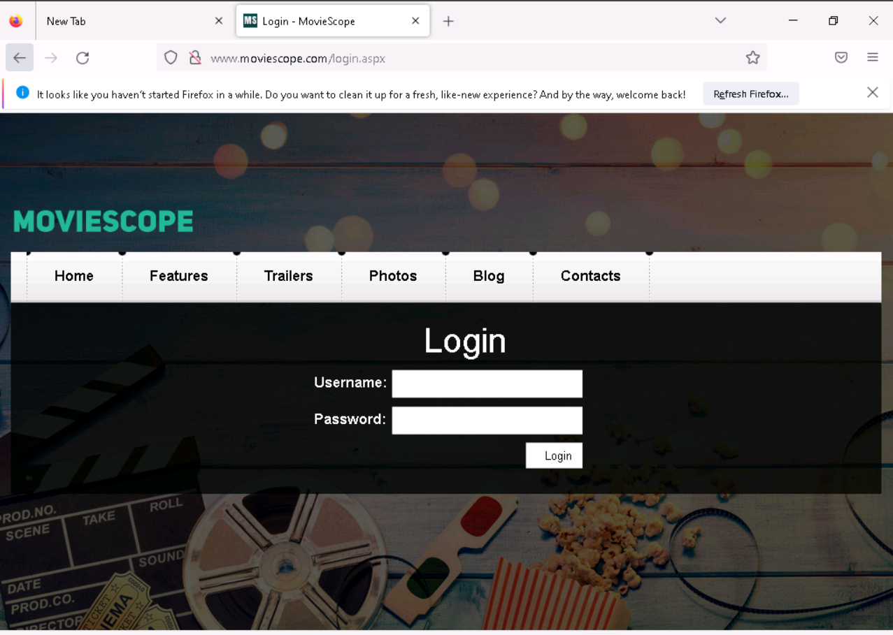

We successfully got the username and password

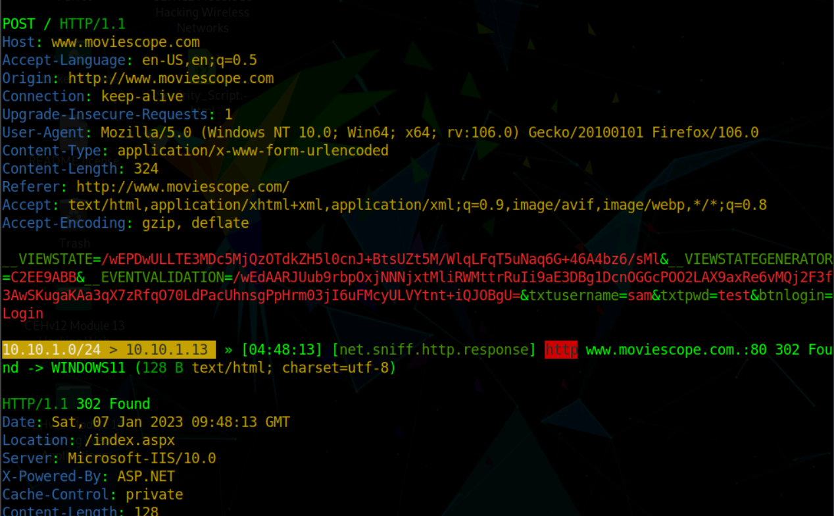

**● Craft the mail containing the malware and send it to the target with spoofed mail that belongs to the internal mail address.**

**Malware :**

Tool:njrat

We are creating a malware using njrat tool

Once we open njrat its show the promp to set the port, here our port is 5552.

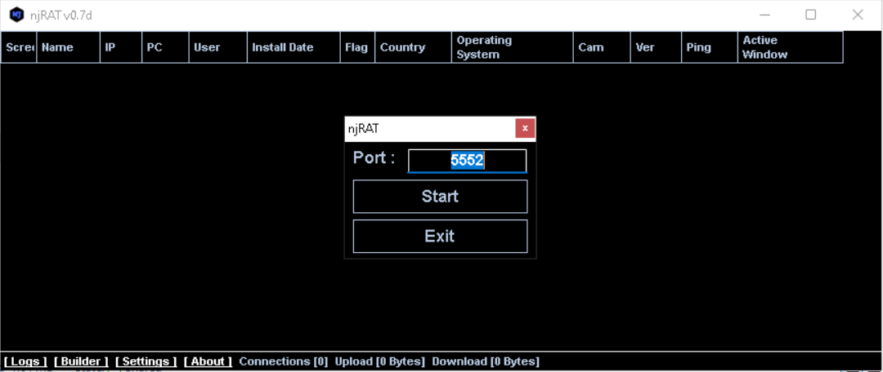

After clicking start we get the dashboard of njrat

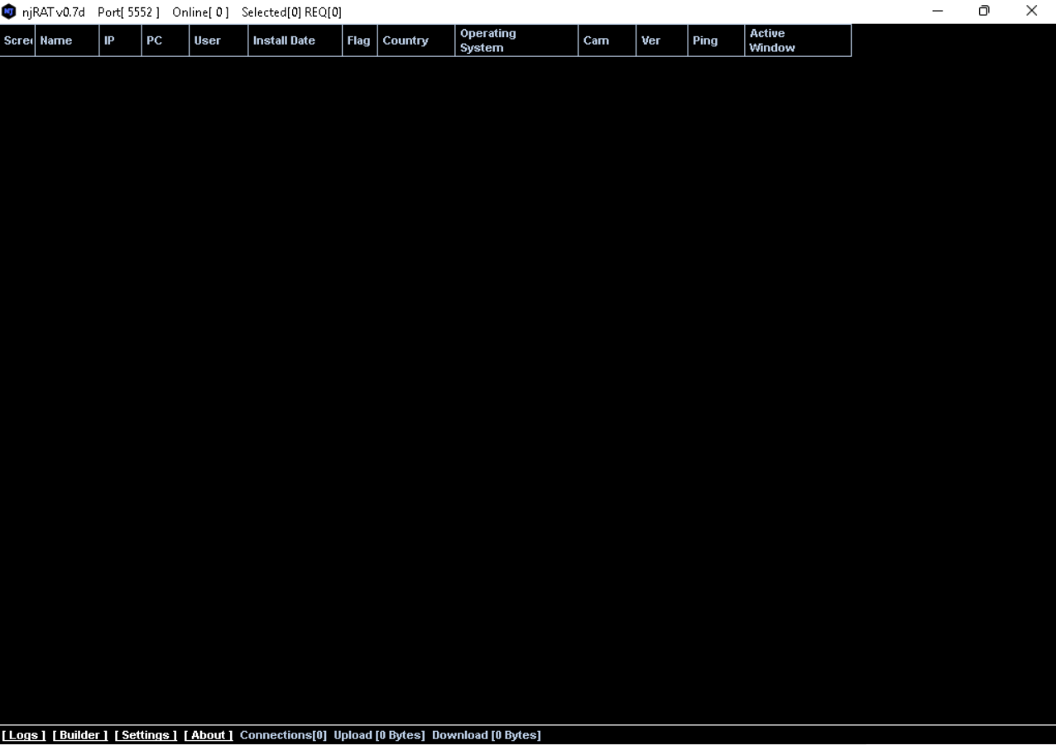

We can find a “Builder” option at the down bar of njrat for build a malware

Builder prompt a window in which we can specify host,port,icon,directory ..etc

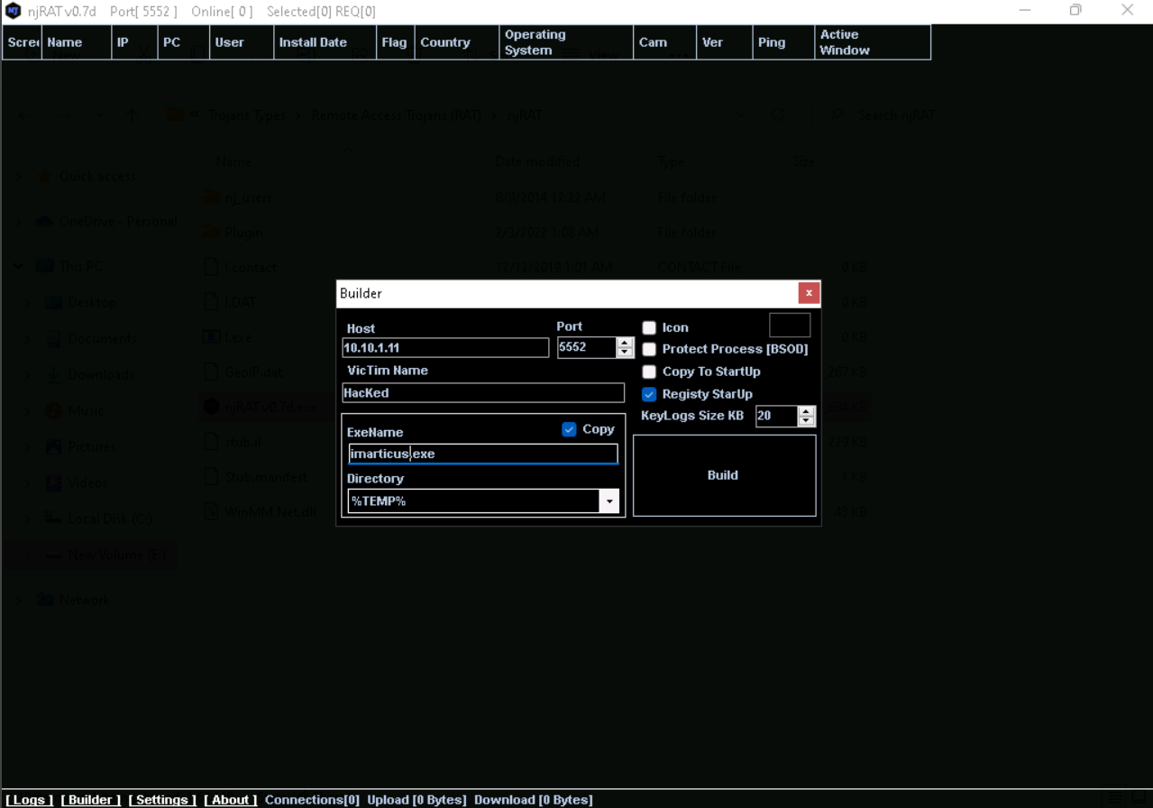

We save the malware with the organization name so it’s look like legitimate for end user

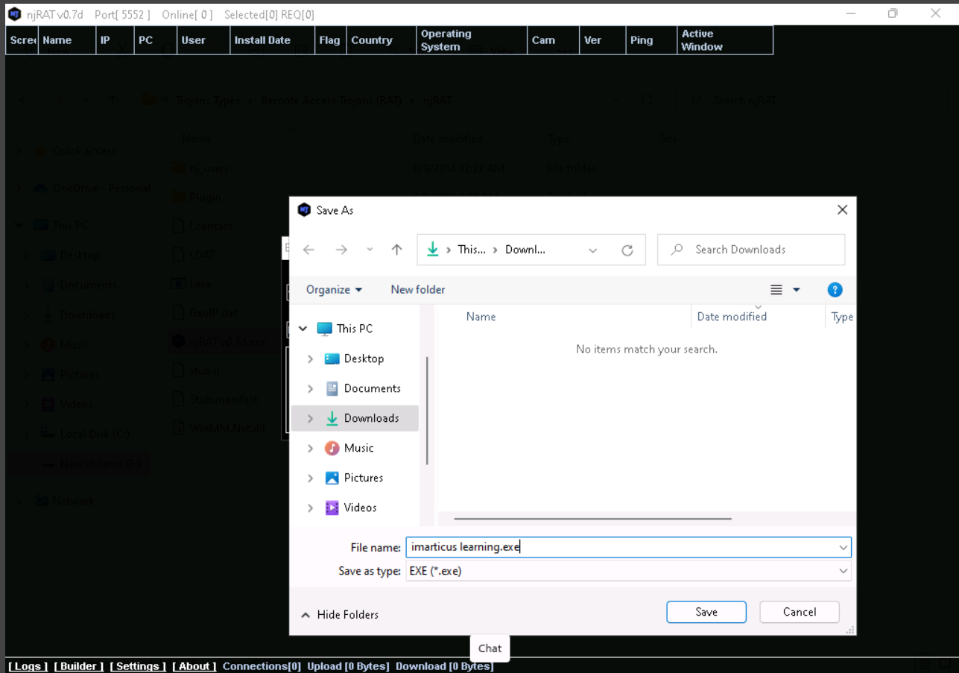

**Victim system**

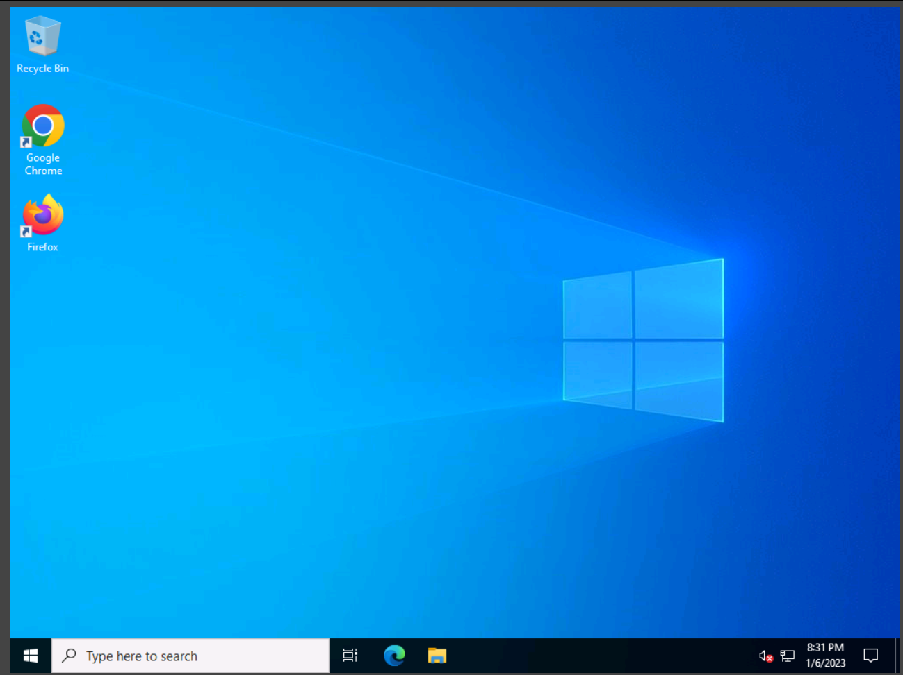

In parrot we are starting apache server in that we can upload our malware on server so the user can browser it

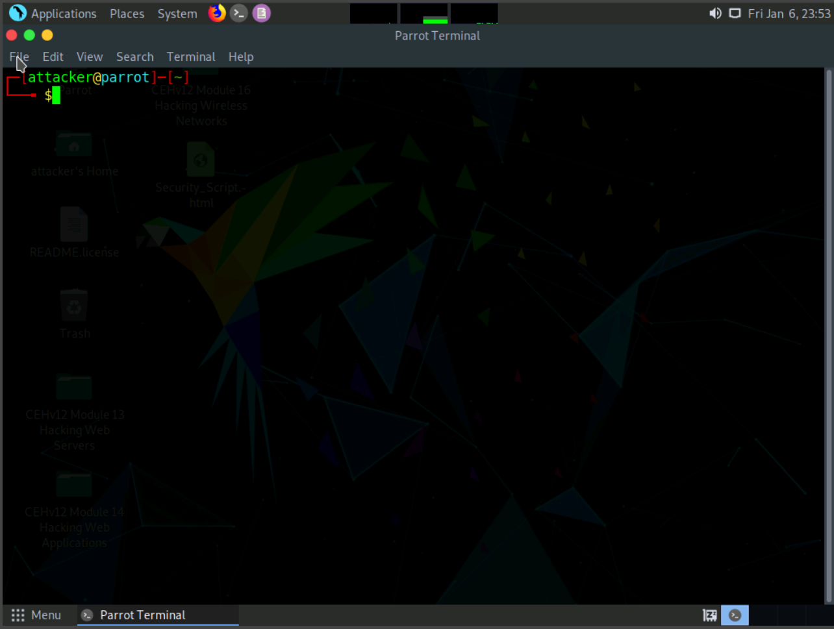

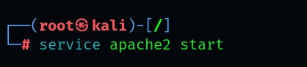

We make a directory in html named share, put the malware in share directory

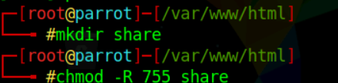

Now we are going to perform the main stage known as social engineering.

As a professional hacker or pentester you have to be able for making a phising mail which look legitimate that user think this is normal or genuine.so user click link or any attachment with out any hesitation.

1.Open gmail

2.click on compose

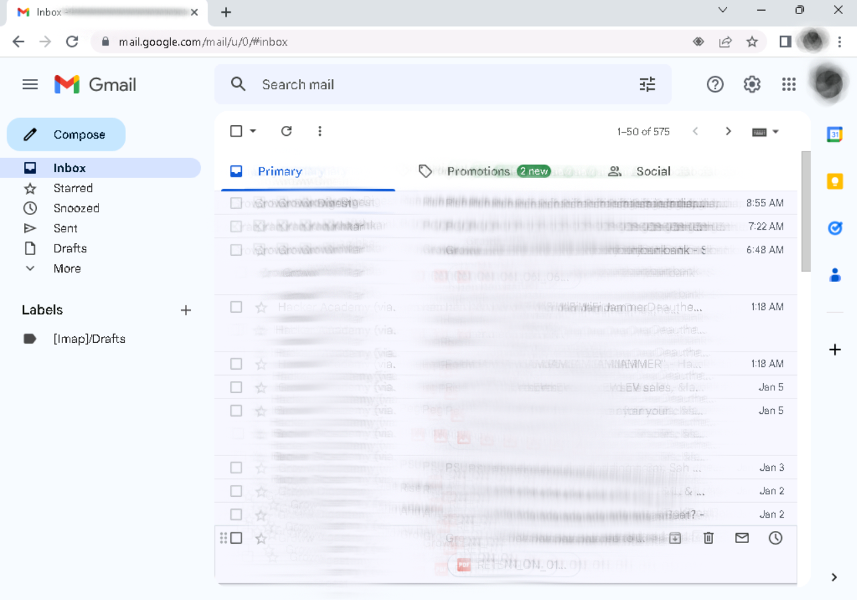

3.Once you click it open a window for writind and sending new mail

4.write a mail which is professional or tempted.

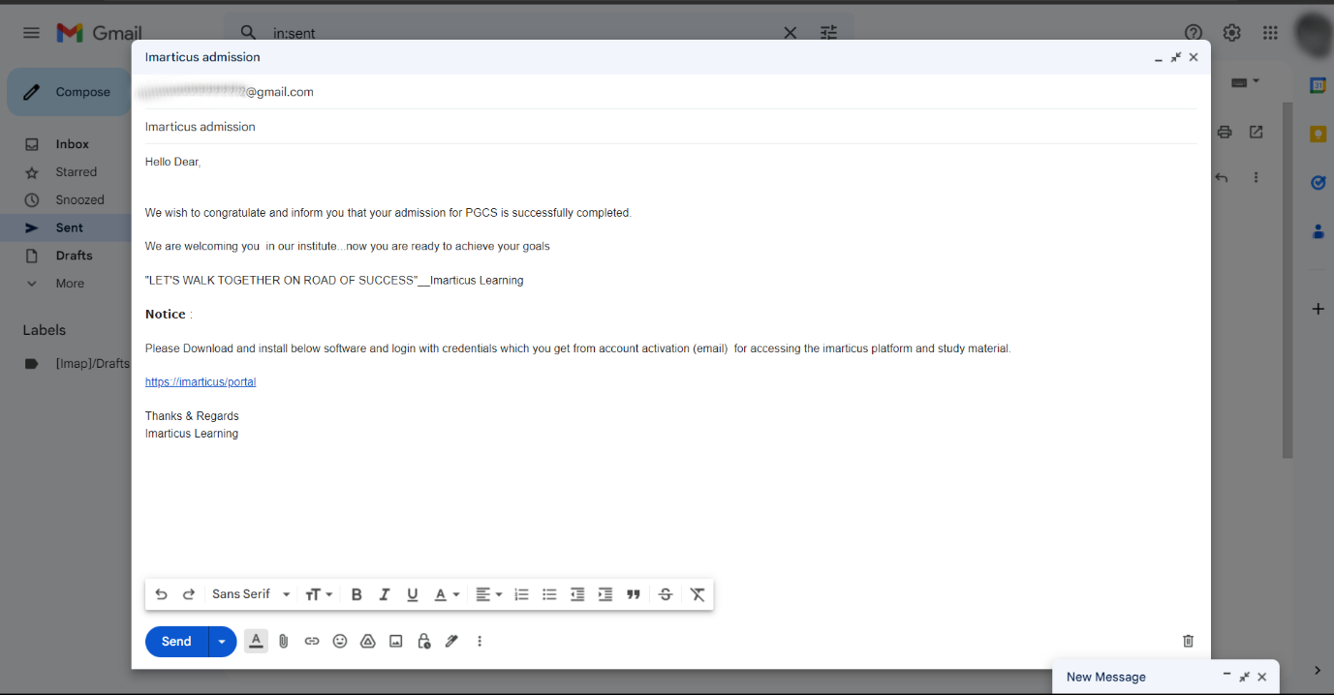

5. hide the original url .

You can see in below image our malicious url is <http://10.10.1.13/share> and we are hiding or masking that url with <https://imarticus/portal>

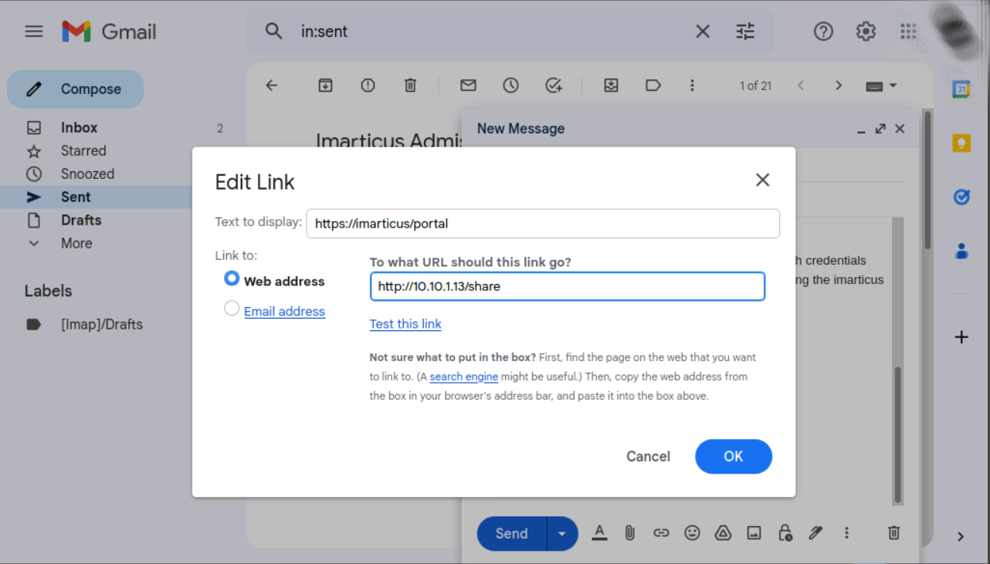

The user got the mail it’s like this:

You can see the link in mail which we masked as <https://imarticus/portal>

Once user click on it, the link redirect to the malicious link

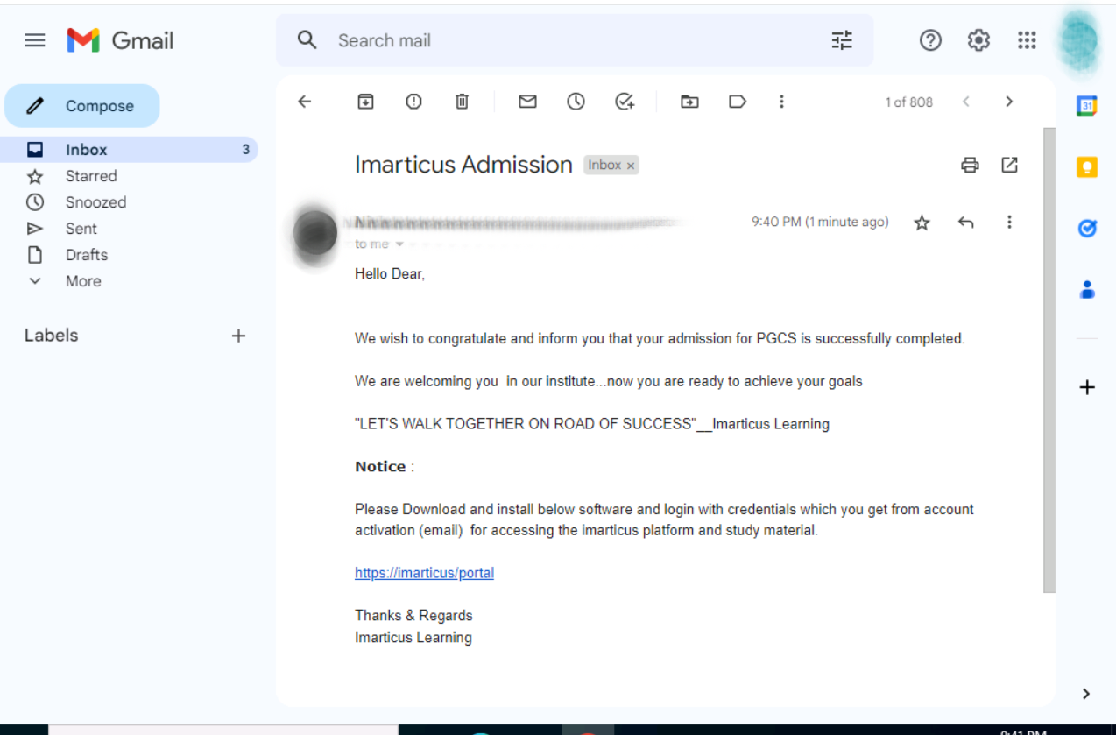

Because of we craft mail as it’s seems like it’s from organization so user download our malware and think like he or she downloading the original software provided by organization.

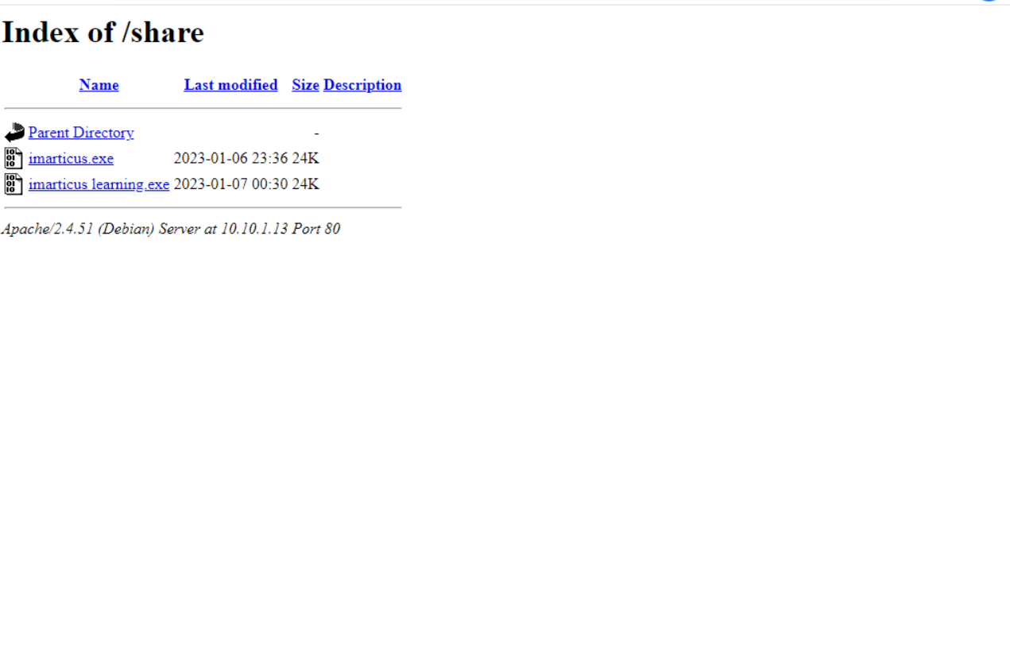

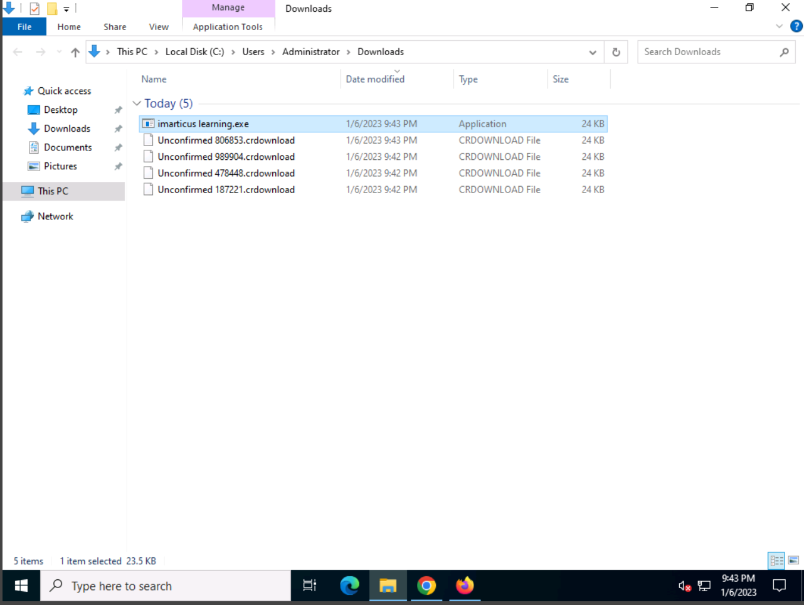

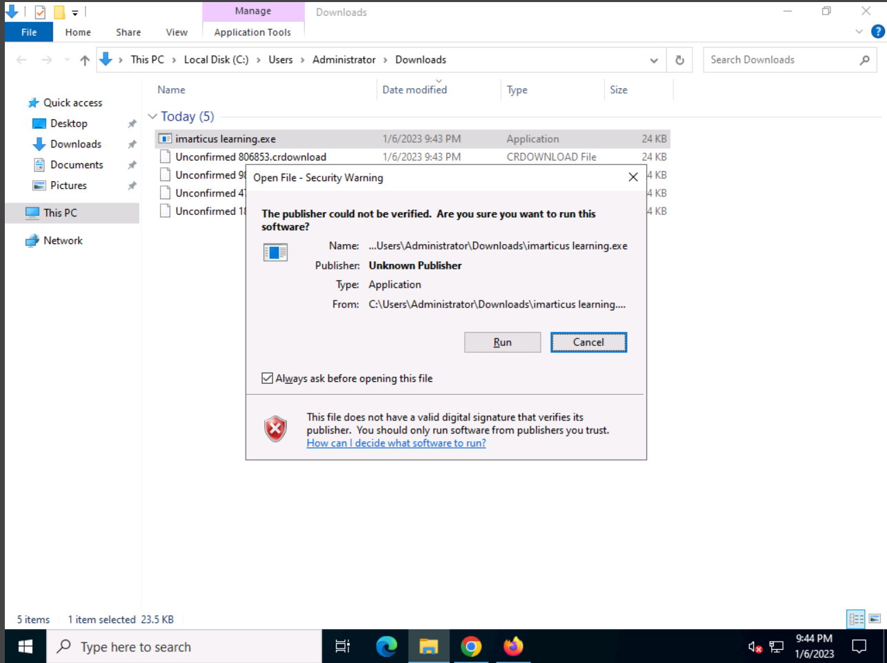

Once the user download the malware and install it at a time we successfully exploited and get the access of target or victim system

Which we can see in below image

We successfully get the access of target system

The details we are able to see:

Name:HacKed_64f81Af7

Ip:10.10.1.22

Pc:SERVER2012

User :Administrator

Install date:23-01-06

Country:N/A

Os: Win server 2022 standard dsp0 x64

Active window:Downloads

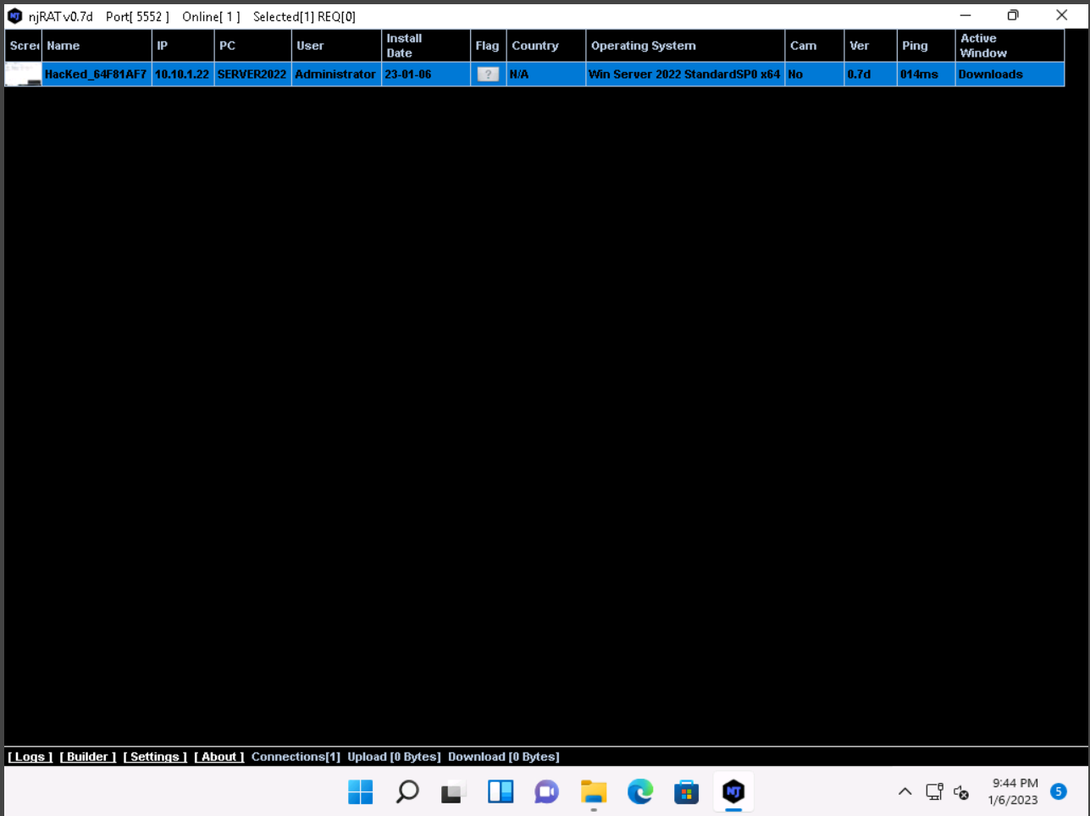

Through right clicking on the tab we can see dop down list.

We can perform all the things which under the drop down list

Manager

Run file

Remote cam

Microphone

Get passwrods

Keylogger

Openchat

Server

Openfolder

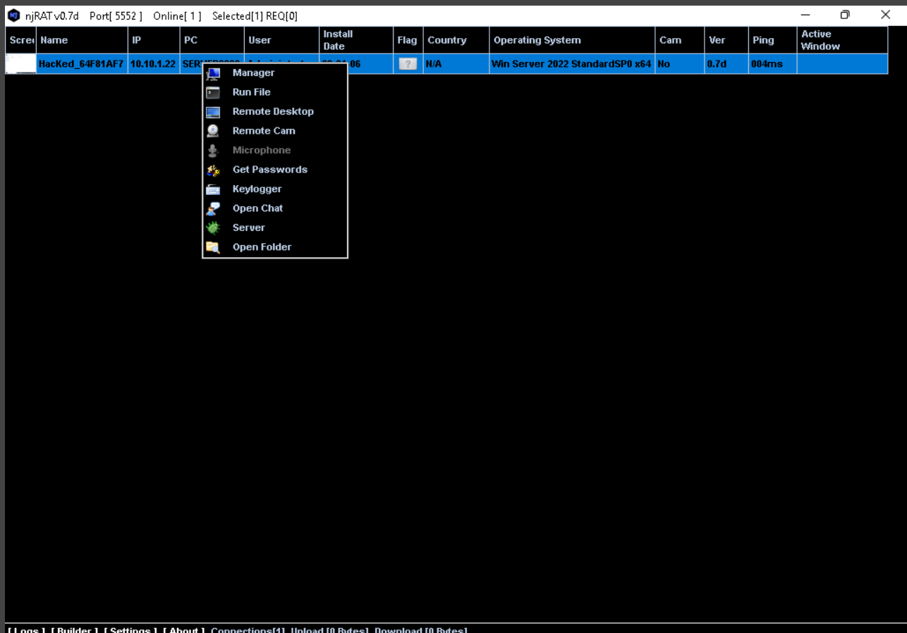

**Victim system…**

**File manager :**

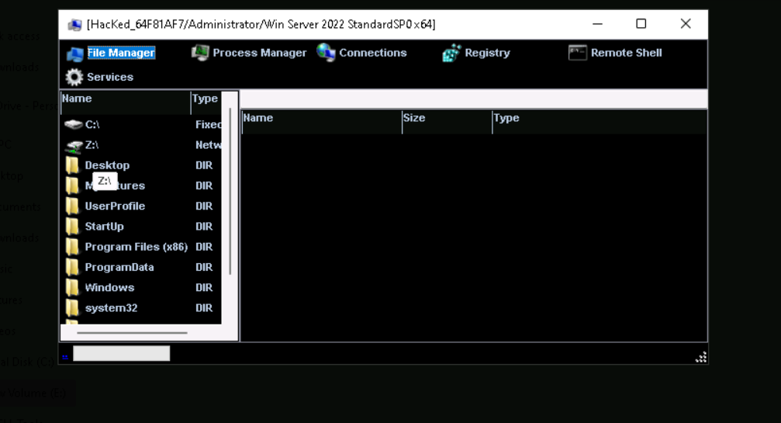

**Services:**

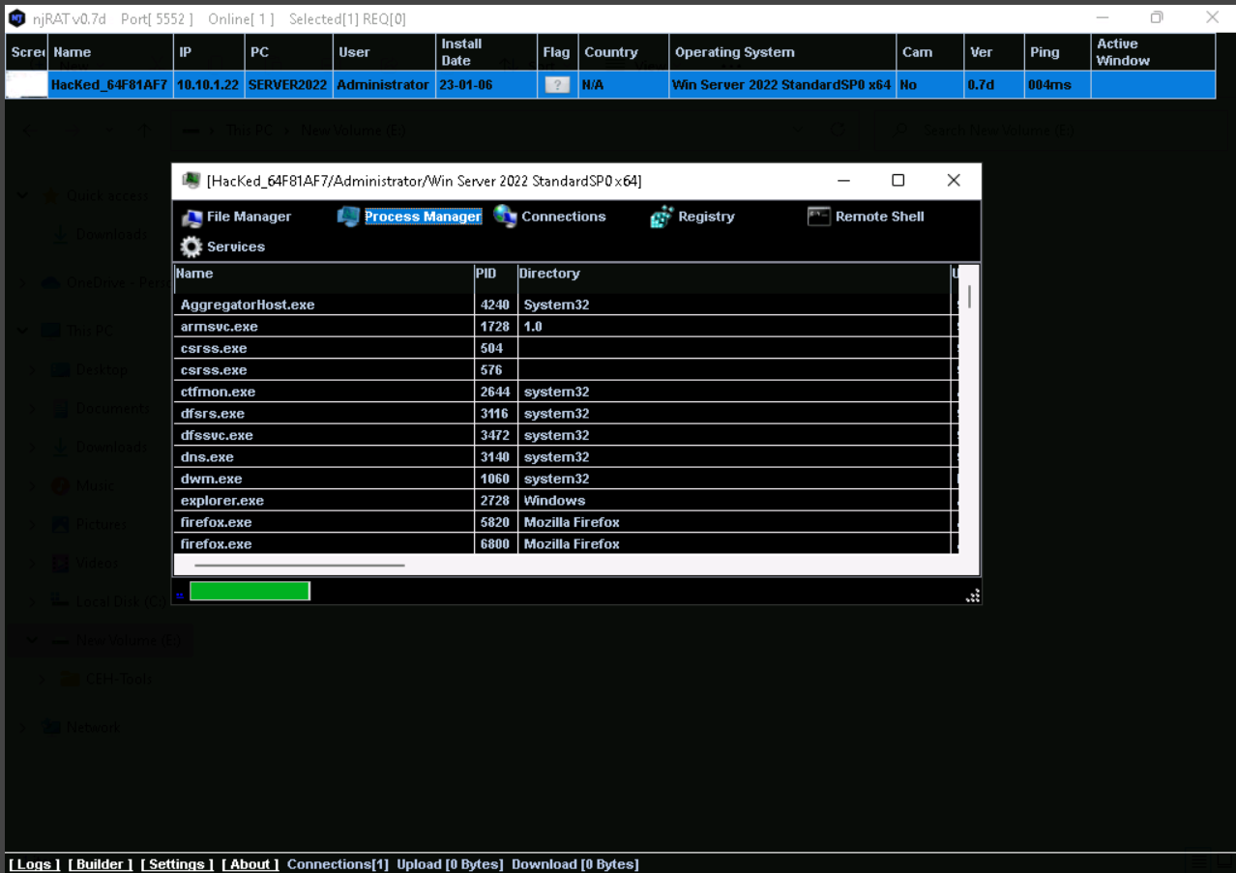

**Registry:**

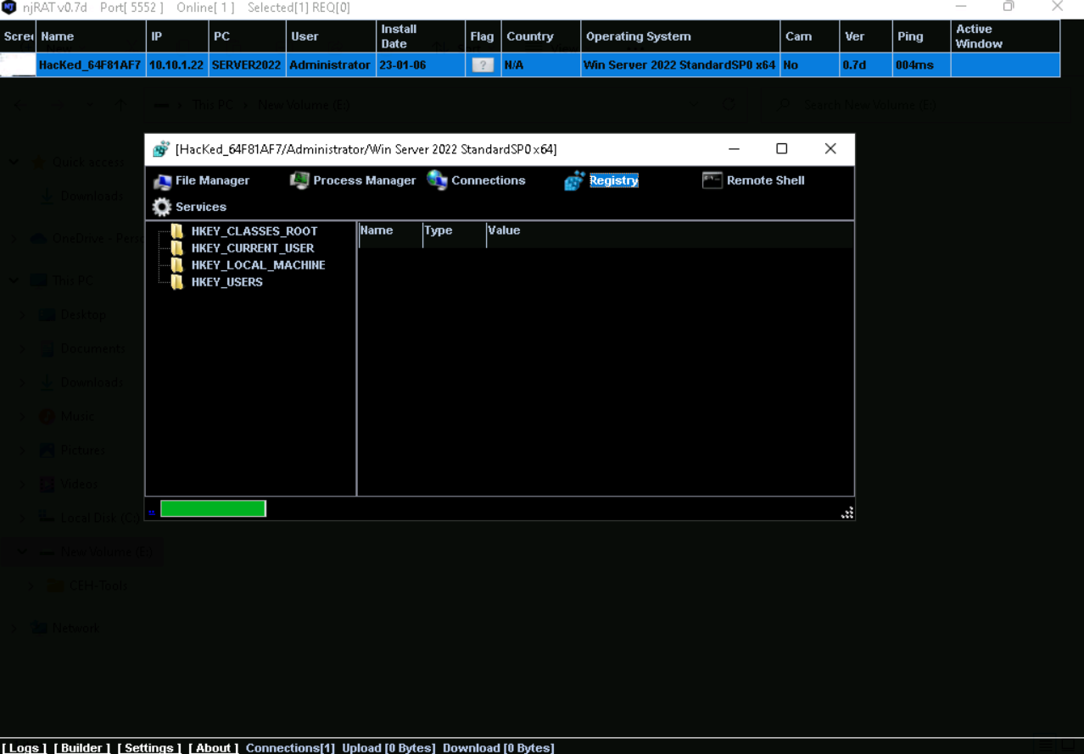

**Command prompt :**

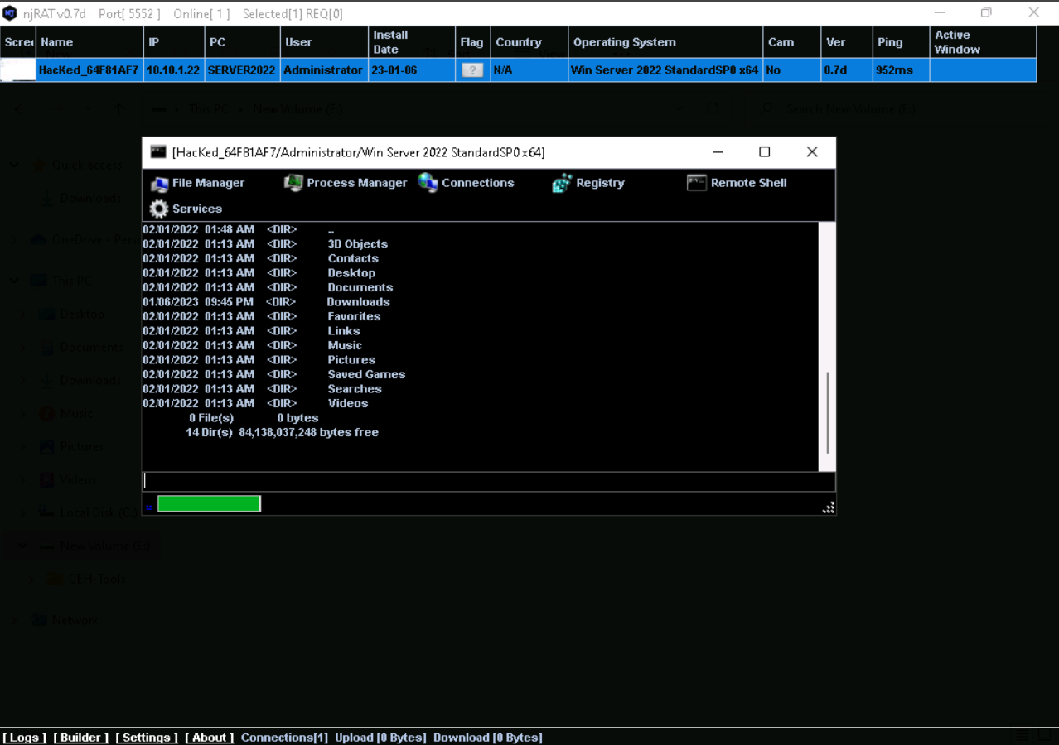

**Remote Desktop:**

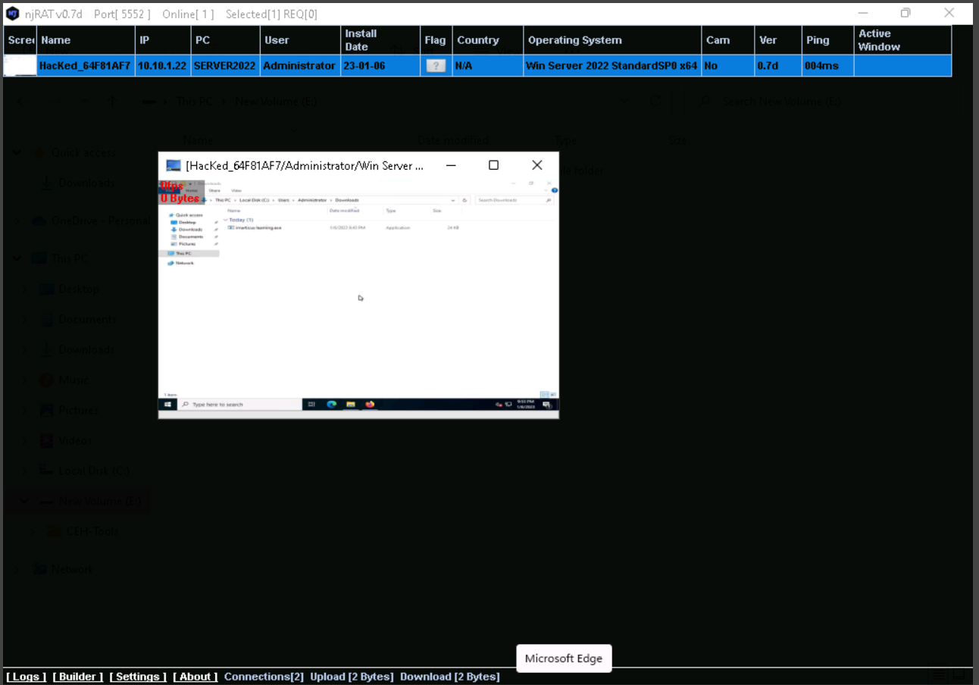

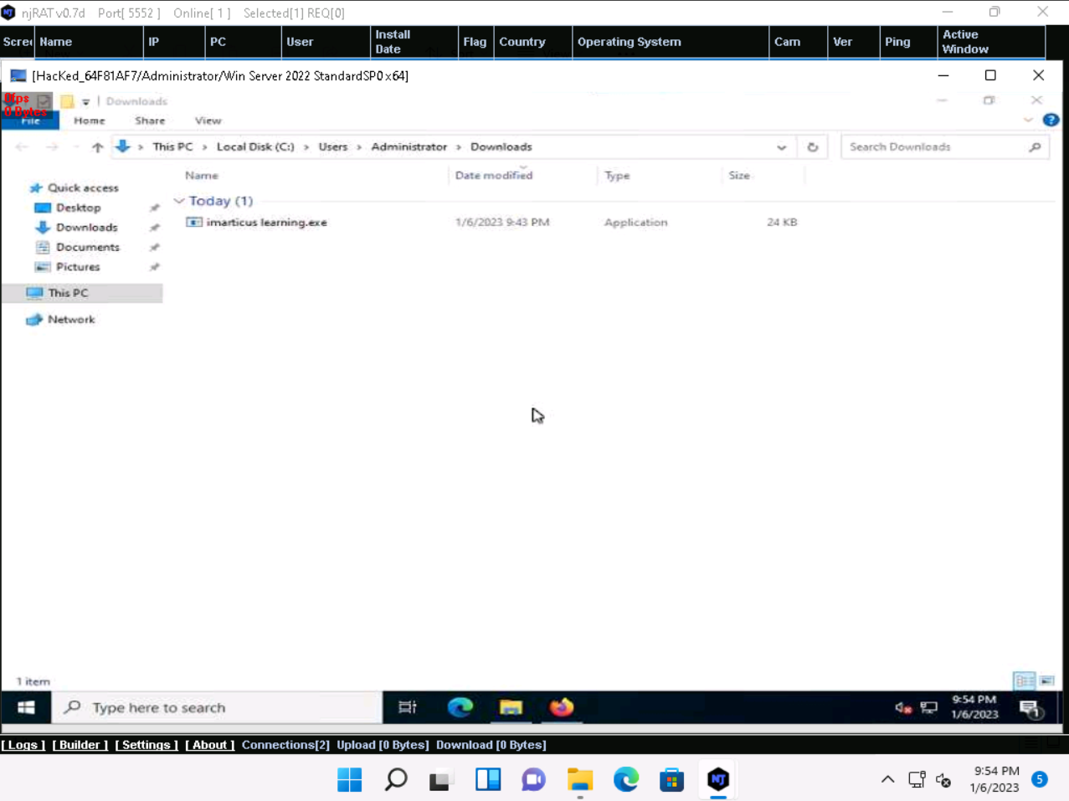

**Keylogger :**

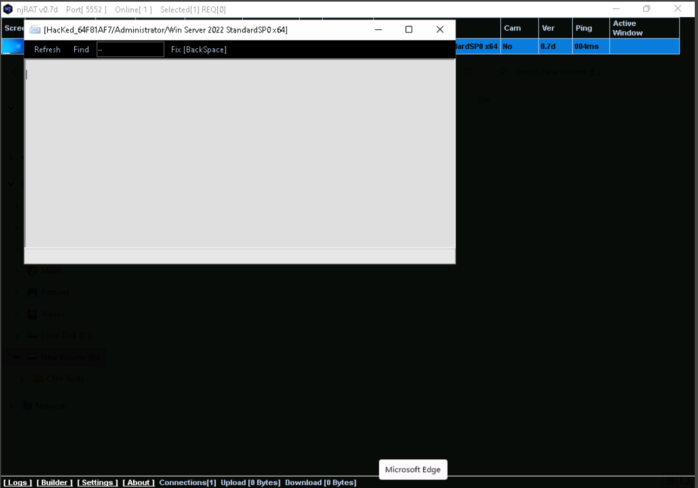

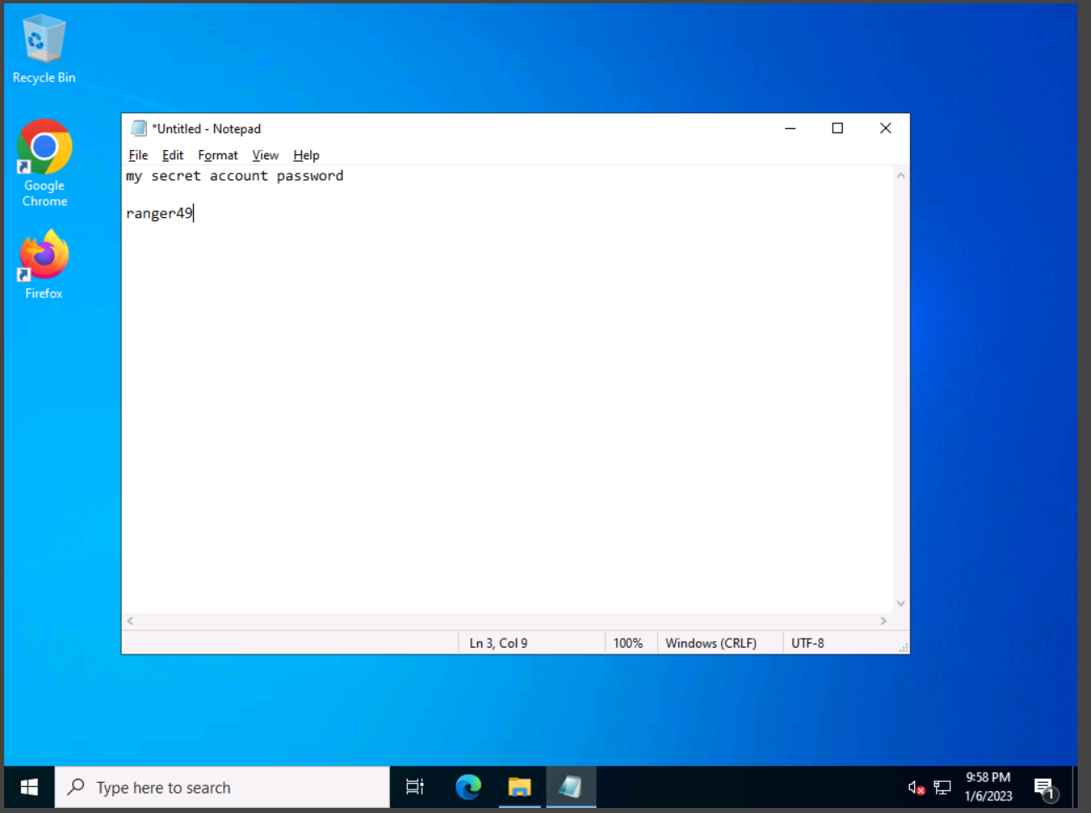

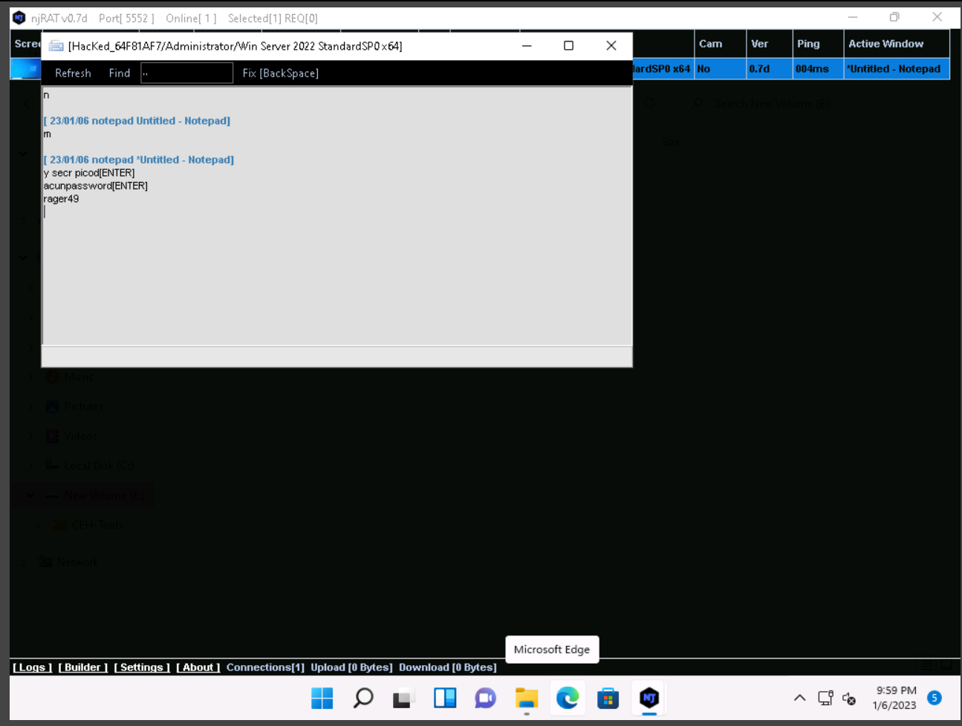

**Chat:**

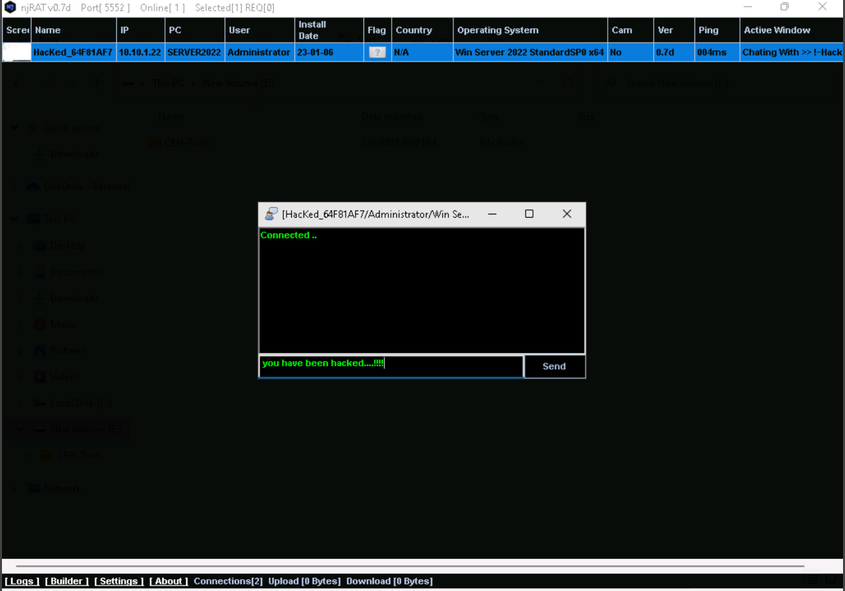

User get prompt window showing the message “you have been hacked..!!!”

